Home Menu

#### Expalanation about Different type of Paste:

### Vertical to Horizontal Data Arrangement(column to row)

### Ex.

## Vertical Data

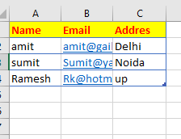

## Horizontal

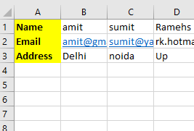

**Step:**

1. Select the Source Data(Vertical Data) -> Copy
2. Select Destination( Where we want to Paste) Home Menu-> Paste Option Choose ( Transpose)

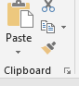

# Difference Between Cut and Copy

## Cut and paste

Cut remove Form Source address ( Where data already Available)

## Copy Paste

Copy Paste keep the Data At Source Address

## Format Painter

It is used to copy the Design form one place to another place

**Select Data** where we want to ***pic the Format*** -> choose the **Forma Painter**  from Home menu to clipboard Ribbon



**Copy and Paste: -** Copy Paste keep the Data at Source Address (Where data already Available)

## Paste as Value:

## 

## Paste as Picture:

## Paste as Format:

## Paste as Both fromat and Value:

## Design the Format as given Below:

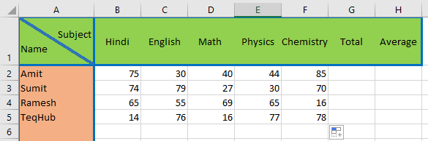

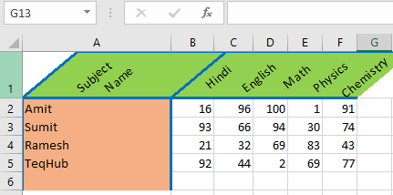

#### Accounting Number Format

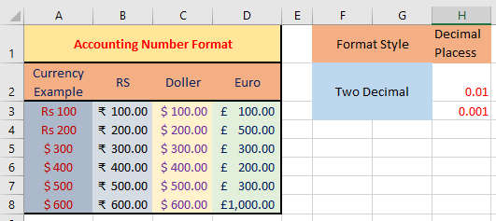

Currency: - It is used to indicate the negative number format and mention the number of decimal place.

Accounting-: It is also related to currency but there is not any special format for the negative number.

Date: - There are given some predefine data Format that can use or apply on the **Date** data Directly.

Time: - Time is also similar as Date bcz It’s also given predefine **time** format.

Percentage: - It only set the Decimal Places.

Fraction: - It set the data Format as **½ 8/16, 16/32**etc.

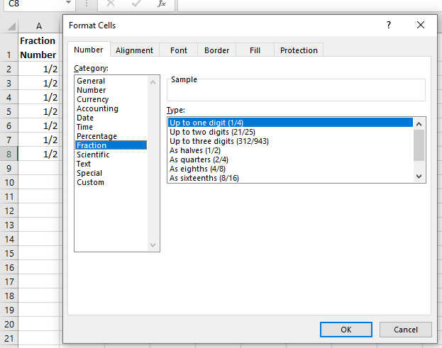

#### Conditional Formating:

Conditional formating is used to fromat the data on the basis of the condtion such as less than, greater than, equlto , between etc.

Condition may be based on cell value, average based Icon and that may be based on the Recored scuch as top ten

Remove The Duplicate Value:

* How to apply the Filter on Data:-

Select Field Name/coloumnName/Top row of the table Data=> **ctrl+shift+L (To add/Remove filter)**

**Or**

Alt d, f,f

#### Text that Contains: -

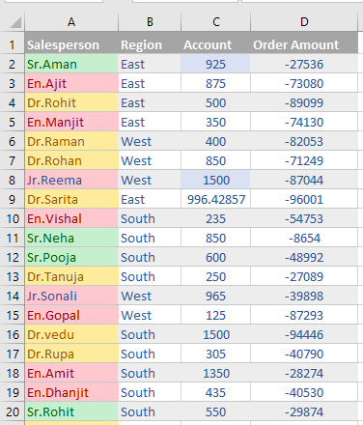

1. Amount Between 200 to 500 => **Color yellow**
2. Amount Less the 200 => **color Red**
3. Amount Greater than 600=> **color Green**
4. Amount equal to => **Red Text**

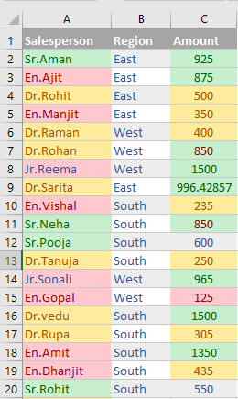

1. Today => **Color Red**
2. Tommorrow => **Color Green**
3. 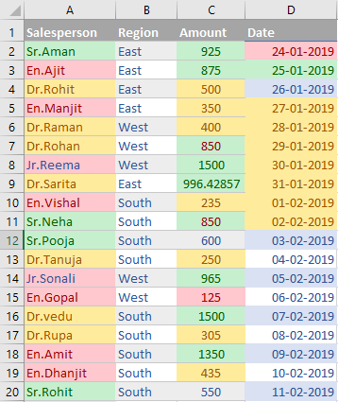Next Week => **Color Yellow**